2026
FUN IN THE SUN
SUMMER RECREATION
PROGRAM


Parent Handbook

Dear Summer Rec. Families,
Thank you for taking the time to review the 2026 “Fun in the Sun” Parent Handbook. We are incredibly excited to be back for another season of our annual summer camp. We look forward to providing daily activities for our Oakland children in a fun and safe manner. Please take a close look through the handbook to see how we will operate this summer.
Here is a brief program overview. More details can be found throughout the handbook:
- Fun in the Sun is excited to return to Williams Elementary School. The RSU 18 staff have been very gracious to work with us over the years, and we thank them for letting us use their building and play areas.
- The program will return to our traditional format of two sessions of three weeks. Session 1 will run from Monday, June 29th to Friday, July 17th. Session 2 will run from Monday, July 20th to Friday, August 7th.
- The cost of the program will be $100 per child for the session, Oakland residents only. Children may only attend one session. Non-Residents will be charged $150 per child and will register after Oakland Residents.
- The program will continue to take place from 8 A.M. to 4 P.M.
- The program is open to children ages 6-12. Children who are age 5 and are about to complete kindergarten will be eligible for the program.
- We offer a Counselor in Training program for those children in grades 8-9. Applications can be filled out at the Oakland Town Office or by reaching out to aparker@oaklandmaine.us.
We will continue to offer many classic, favorite activities and events for the children to enjoy, including sports and games, recreation and education options, sports clinics, special events, field trips, and much more!
We look forward to having a great summer with your children!

Sincerely,
Oakland Recreation Department

Program at a Glance
Arrival & Departure
Camp hours run from 8:00 A.M. to 4:00 P.M. We ask that you do not drop your child off before 7:45 A.M., as we cannot guarantee coverage prior to this time. One half hour prior to field trips is acceptable. Parents will be given a fifteen-minute grace period after 4:00 P.M. Any time after 4:15 P.M. will be billed for an available staff member to cover. Upon arrival, please pull into the bus loop out front to drop your child off.
Upon arrival to pick up please pull into the bus loop out front. Someone will come to your car to ask who you are here for and then they will have you sign out the child. We may ask to see the I.D. of the person picking a child up if we are unfamiliar with the person. Please ensure that all people allowed to pick up your child are listed on the registration form. It helps to remind a staff person upon arrival that someone different will be picking your child up. We want to ensure your child’s safety.
If you plan to pick up your child early, please communicate this at drop off.
Day to Day
If we do not have a field trip planned, we will be at Williams or surrounding areas of the schools from 8:00-4:00. Campers will get a choice of activities they would like to do during the day that range from sports and games, recreation and education options, and arts and crafts.
Food
The school nutrition program will provide snacks and lunches for our camp again this year. All children are eligible. Parents are welcome to send their child with additional snack/lunch if they choose. Breakfast will be from 8am-9am and any remaining snacks will be used for our normal snack time. Our snack will take place at 9:30 A.M. and lunch at 11:30 A.M. There is no additional cost for this program.
All campers will eat snack at 9:30 am and lunch at 11:30 am. Lunch will take place at the Middle School as that is where lunch is provided for them. Campers are not forced to eat the school lunch but are welcome to it if they do not want to bring one.
After lunch campers will continue to enjoy a day full of activities they can choose from until pick up time.

Behavior Plan Policy
We expect campers to have fun, to be treated fairly and respected, to respect others, to keep hands and feet to self, bring, follow the rules, make new friends, and have a blast! Threatening, swearing, unsafe behavior, disobeying counselors, misusing, or destroying camp property, bullying, and other extreme behaviors will not be tolerated at Fun In The Sun. Fun In The Sun has adopted a strict behavioral policy with specific responses to issues that may arise. Parents will be informed in writing of any camp rules that were broken and must respond to such notifications should they occur.
Severity Consequence:
Level 1- A verbal reprimand or ‘cue’ will be given by the staff member to redirect the child to a more appropriate form of behavior.
Level 2- The Child, under staff supervision, will be removed from the group for a few minutes and will rejoin the group when the staff member has determined that they can do so without further disruption.
Level 3- Should the behavior not change; the recreation director will be notified, and the incident will be documented. Parents will be informed, if need be, of the incident and sign the incident report at pickup.
Level 4- Sent home for the remainder of the day and/or asked to take a day or more away from camp. In severe cases this could possibly include suspension from the program. Parents and the child will have to meet with the recreation director to develop a plan to move forward.
The above procedure will be used when there is a gradual progression of inappropriate behavior. In extreme cases, Oakland Recreation reserves the right to establish an appropriate consequence immediately, which may include expulsion from the camp. No refund will be given should your child be removed from camp for any period of time due to disciplinary reasons.
Examples of Misbehavior
• Refusing to follow behavior guidelines or camp rules • Using profanity, vulgarity, or obscenity • Stealing or damaging property (personal or camp property) • Refusal to participate in activities or cooperate with staff • Disrupting a program • Leaving a program without permission • Endangering the health and safety of children and/or staff • Teasing, making fun or bullying of other campers or staff • Fighting of any kind

Program Fee
The cost of the program is $100 per child for a complete session. The camp is open to Oakland residents only. The fee will include all activities, clinics, and hours of supervision each week. (Some field trips will require an additional, cash only fee, to be collected on the day of the trip see the field trips list for more information)
Camp shirts will be provided and are included in the session fee. Camp shirts are required for field trip participation to ensure the safety of the campers. We can keep a much better eye on a group of kids in our colorful shirts!
To provide a safe and productive summer experience, we must limit the number of participants to 100 children per day, per session. Participants may only register for either Session 1 or Session 2 of the program. The session fee is requested at the time of registration (please contact the Recreation Department at 207-465-7357 if you need to make other arrangements).
Financial Assistance
It is the underlying philosophy of the department that NO child will be turned away from this program based on financial hardship. Individual situations can be dealt with in a confidential manner by contacting the Recreation Department at 207-465-7357 or email aparker@oaklandme.gov .
2024 Summer Staff Team
Aaron Parker- Parks & Recreation Director
Justin Bolduc- Camp Director
Olivia Boudreau- Asst. Camp Director

COUNSELORS:
Brynn Arceo
Elsie Spear
Guiliana Roderick
Aldia Willard
Lily Wilkie
Leah Van Tuinen
Grace Moody
CJ Wallingford
TBD
TBD

Special Events
Each week, we will provide special events on Friday! Here is a list of the events for each session.
Session 1 American Pride Day (Fri) July 3rd
Pleasant Point Park Day July 3rd
Tantalizing Talent Show July 27th

Session 2 Wacky Water Day TBD
Pleasant Point Park Day July 31st
Tantalizing Talent Show August 7th

Field Trips

We plan to return to Lake St. George S.P., we also plan to go to Maine Wildlife Park and Sea Dogs games! Listed below are the dates for these field trips!

Session 1 Portland Sea Dogs July 1st
Pleasant Point Park Day July 3rd
Maine Wildlife Park July 7th
Lake St George July 8th
Lake St George July 15th

Session 2 Lake St George July 22nd
Maine Wildlife Park July 28th
Portland Sea Dogs July 29th
Pleasant Point Park Day July 31st
Lake St George August 5th

Lake St George cost is listed below. Please plan to pay for your child’s field trips with cash rather than check on the day of the trip. Also, do not forget to wear your camp shirt! Children should bring lunch (if they do not want the lunch provided), sunscreen, towel, and a dry change of clothes.
Cost: $4 Departure: 8:30 A.M. Return: 3:30-4 P.M.

Maine Wildlife Park (Ages 6-8) is no additional cost to you. Please make sure campers wear their camp shirts and bring lunch if they do not want the one that is provided by the school. There is a gift shop if you would like your child to get anything.

Portland Sea Dogs (Ages 8-12) tickets will be covered by registration fees. However, we are unable to bring lunch into the stadium so you will need to send your child with money to get some food. They do offer boxed lunches for $10. They include a hot dog, bag of chips, and a water bottle. If this doesn’t work, you can send your child with money for different food. Children can also bring money for the gift shop as well.

SCHEDULE (Subject to Change)
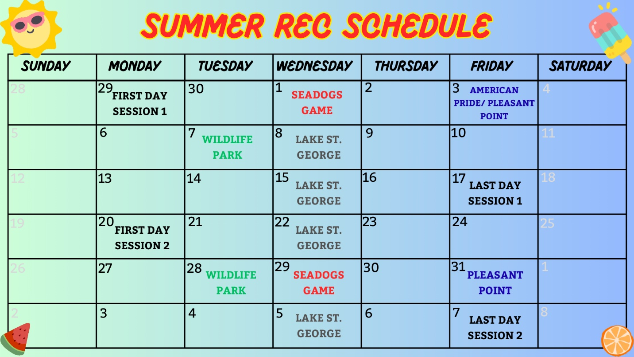

Counselor in Training Program

We are excited to have the Counselor in Training Program back to Fun in the Sun this year! This program is for children who have aged out of our program but are not yet old enough for employment. CITs act as an extension of our staff and are a wonderful resource to our campers. If you have a child interested in becoming a CIT, please contact the Oakland Recreation Department at 465-7357. Depending on numbers, we may limit the number of CITs we take per session.

If you have questions regarding any of the policies in this handbook, please do not hesitate to reach out. Call us at 465-7357 or email us at aparker@oaklandme.gov. Thank you.

